Design Brief Document

## Introduction (Michael)

Team 6 will be producing both the design and implementation of a Dynamically Authored Website for a franchised “Garage car sales” company, located In Northern Ireland. The Company in Question “SpeedFixSales”, Currently has no online presence beyond a Facebook page. They are seeking to build a website that can be integrated into the business as they seek to modernize and expand. There main aim with this website is to provide a more modern experience for the younger generations via an online presence and attracted their business to stay ahead of the current competitors such as “QuickFit” who currently do not have website either. The website in short will highlight all the cars currently for sale from the garage and give their locations if they are offsite. The website will also highlight all the garage’s mechanical services and advertise some of the products the garage can offer.

The Development Team will be using the following workflow task management systems, firstly version control will used using both GitHub and GitHub Desktop/Git. The Team will use the Kanban System via Trello Website, to track task progress and identify blockers. Weekly Meetings will be held once per week at the weekend using Zoom Video Calls, where the next weeks tasks will be formalized into stories/tasks on Trello and assigned equally among the team. Each meeting will have minutes recorded. Finally, we decided to use WhatsApp for the bulk of communication, as its accessible easily via phone, which suited everyone’s Work Lifestyle.

The Team initially uses the following technologies (subject to change, as required):

HTML, CSS, JavaScript (JS), Bootstrap JS Library

Team Members will use differing tools to produce wireframes, as we do no know which tool is ideal, and will ultimately choose the best tool for the final Wireframes:

Microsoft Visio, Balsamic

## Target Industry / Audience (Adam)

This site should be tailored to all demographics except for children. Within car sales industry the target market is anyone who may wish to buy a car, with this the website must be simple for all age ranges to use in order to drive traffic and as a result of this more sales. However, the main goal from creating a site is to gain an online presence to draw a younger audience.

## Competition (Lewis)

Researching into the competition for Garage car sales a lot of business seems to be local and not have any online presence or identity. Some competitors will; be using websites where they seem to rough and do not look professional. I will be looking at 2 competitors’ websites to their strength and weaknesses of their websites and using that information to analyze what to include or build on, in our own website; and what to exclude on the website. The three website I will be looking at will be:

1. <https://www.shelbournemotors.com/>
2. <https://www.autotrader.co.uk/>

Starting with the first website Shelbourne motors, looking at the home page overall there is a lot of information and images which seems to be overwhelming on the screen. Making the website look untidy and difficult to navigate. Also looking at this there is a lot of features on the homepage to search for a car, a quick search, look through a listing, and another search option in the menu bar. Looking at he used car page; gives a simple listing of available cars, with details on the make & model, price, millage, and other relevant information, with a full image of the car. When clicking on a specific car it takes you to a page with the full image and details, this page has the same problem with the home page where it is highly cluttered. Looking at the new cars it is not formatted like the used cars, instead it takes you to a list of car makes with a description about the company that manufactured the car. Which seems pointless as it could be done using a filter for the makes of the car.

Looking at all this information in the context of implementing our own website, you can make the case that less is more, by not overwhelming the page with information and features of the site. Looking outside of car retail and looking at other ecommerce sites; where there is more of an emphasis on simpler designs and features like Amazon. Where it would be easier to look at and to use making a better way to purchase a car if we keep these ideas in mind. Looking at some of the features and functions that are offered that can be implemented like the quick search or the simple layout for the used cars. Using these features and expanding on these features to make navigation of the website and searching and filtering for cars for a greater user experience.

Looking at the second website autotrader.co.uk, first impressions the homepage looks very polished and professional. The layout of the website is simpler looking, while offering the same features as a quick search and a filter for cars. Also showing the latest best deals for cars on the homepage. With the tidier looks of the website and the features being more organic on the webpage rather than forced upon a user, making the good ideas for a more simple and smart design. Looking at the used cars section of the website it falls into the same traps as the first website, where you do not get a direct listing of cars but just makes of cars you can pick from. But adds in a good feature where you can search used cars by location.

Using this information, we can take insight from the layout and the simple look from the website for a tidier and more functional website compared to the other websites looked at. This website looks and feels professional, where you could trust buying and selling a car from, giving the business a good reputation just down to the style of the website. Going to the cars section the style that was previously mentioned matches the quality of the other pages. But like the first website they make extra steps involved from viewing actual cars. Where if we were implementing our own website, you could have the lists of cars with the filtering could be applied making it an easier experience to just browser cars. Overall this website has a lot of good aspects with the design and features which can be utilized and built upon with the simple design and features making it an easier user experience to navigate the website.

## Corporate Identity (Adam) – Logo, Font, Colours

Logo:

Font:

Noto Sans – chosen due to its professional look.

Colours:

Dark Blue White Yellow

These colours were chosen as when combined they give a simple and professional look.

## Objectives (Patrick)

1. Company objectives
   1. To beat competitors to the market
   2. To sell cars and car parts on the internet
      1. Providing the location of each car/part/garage
   3. Reach a wider target audience.
   4. To be able to buy cars off customers.
   5. To establish a way of customers communicating with them
      1. Via email, phone, or newsletter
2. Team Objectives
   1. Build a website that is easy and intuitive to use.
   2. Make a website that is visually appealing.

## Final Wireframes (Adam) – Home Page

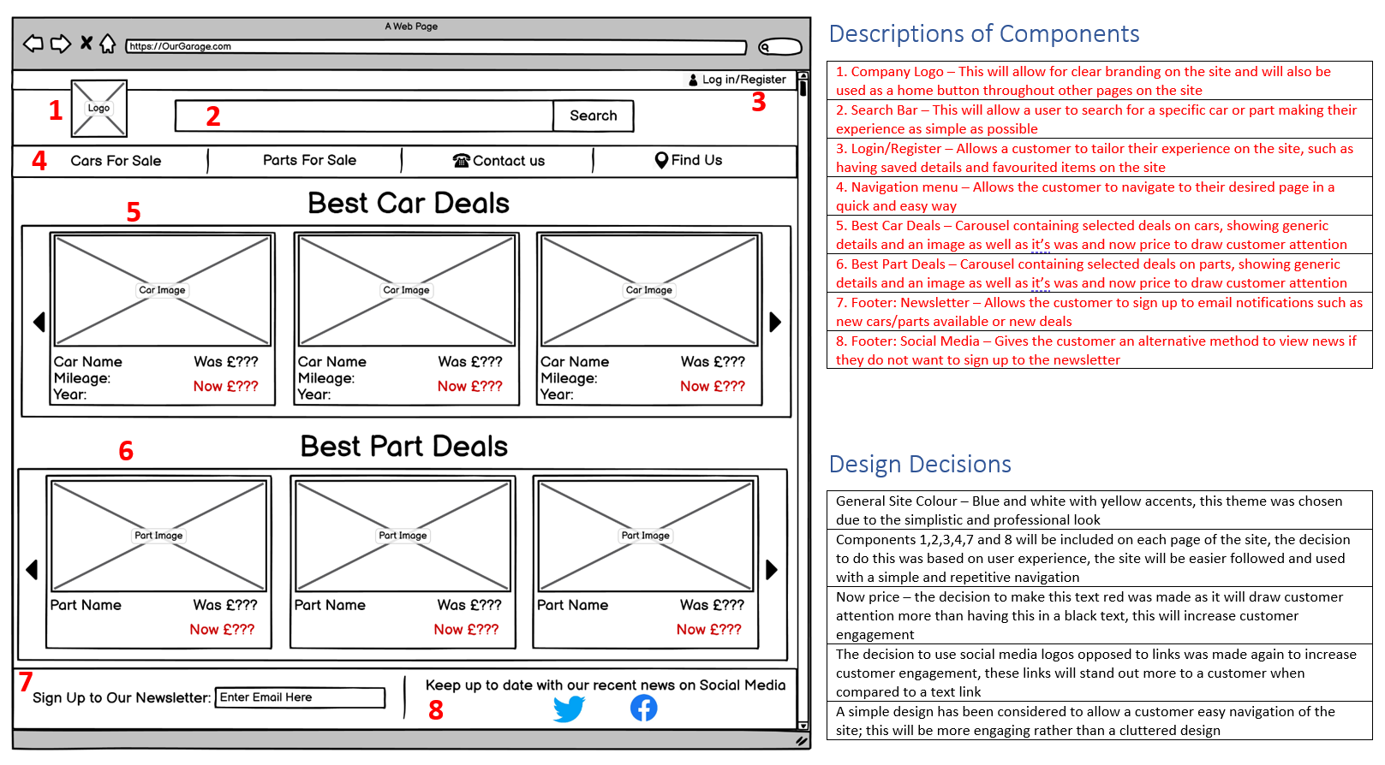

## Final Wireframes (Michael) - Car Listing Page

## Final Wireframes (Michael) – Single Car Details Page

## 

## Final Wireframes (Lewis) – Part Listing Page

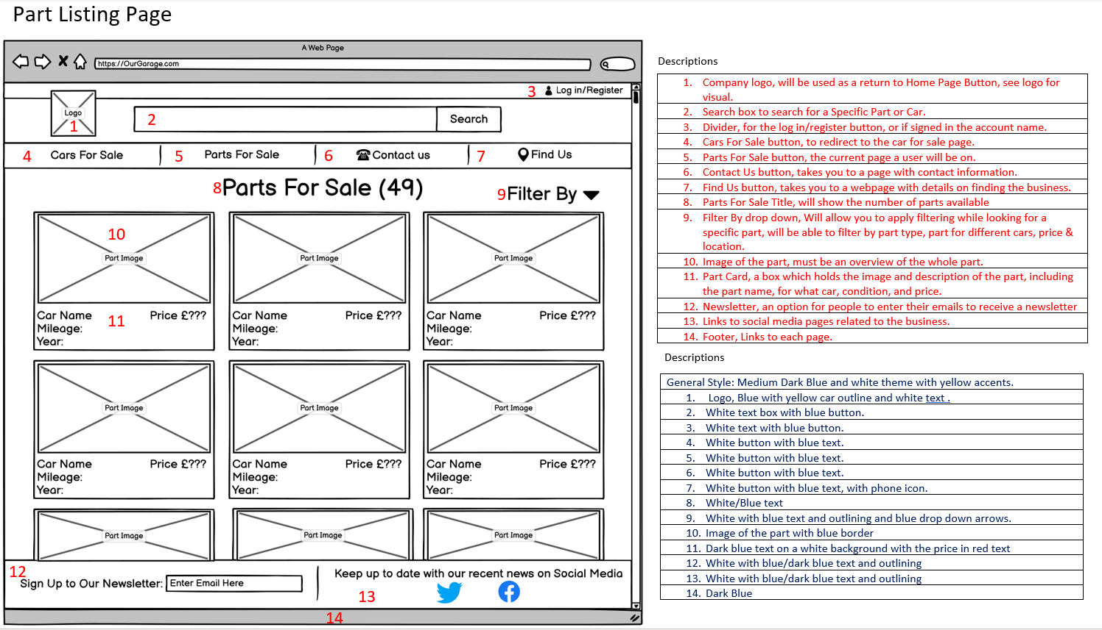

## Final Wireframes (Patrick) – Single Part Details Page

